[CEN 323 ] Computer Organization & Assembly Language
Lab 8 Journal

Name :Bilal Aamir
Enrollment Number: 01-135232-16

Lab Deliverables (submission guideline)

Create a folder named after your enrollment number and add the following files:
  - Create a folder named YourRollNumber_Lab8 containing:
- .asm files of the three practice tasks.
- 4 .asm files of the mid term exam
- Add full screen screenshots of the code and output in this word file.
  - Zip the Folder and upload to LMS.

Mid Term Exam Tasks

Question No. 1.
Write a program in assembly language that takes a single digit number from the user ;
- If the number >= 5:
  - Check if the number is even, if it is even, divide it by 2 and print the result.
  - If it is odd, multiply it with 2 and print the result (If the multiplication result is two digits, print it accordingly)

- If the number < 5: Message is displayed, “Number is less than 5”.

Code (TEXT):
.data
msg db 10,13,"Enter the number : ",10,13,"$"
msg2 db 10,13,"The number is less than 5 ",10,13,"$"
num db ?
divv db 2
msg3 db 10,13,"The number is : $"
div2 db 10
quot db ?
rem db ?
strquot db 10,13,"The quotient is $"
strrem db 10,13,"The remainder is $"
.code

main:
mov ax,@data
mov ds,ax

mov ah,09h
LEA dx,msg
int 21h

mov ah,01h
int 21h
sub al,48

CMP al,5
JL LessThan5
mov num,al
xor ax,ax
mov al,num
div divv

CMP ah,0
JE Even
JGE Odd
Odd:
xor ax,ax
mov al,num
MUL divv
mov num,al

CMP al,10
JGE double
JL Single

double:
xor ah,ah
div div2

mov cl,al
add cl,48

mov bl,ah
add bl,48

mov ah,09h
LEA dx,msg3
int 21h

mov ah,02h
mov dl,cl
int 21h
mov dl,bl
int 21h
jmp Cont3

Single:

mov ah,09h
LEA dx,msg3
int 21h

mov ah,02h
mov dl,num
add dl,48
int 21h

Cont3:
jmp Cont2

Even:
xor ax,ax
mov al,num
div divv

mov quot,al
mov rem,ah

mov ah,09h
LEA dx,strrem
int 21h

mov ah,02h
mov dl,rem
add dl,48
int 21h

mov ah,09h
LEA dx,strquot
int 21h

mov ah,02h
mov dl,quot
add dl,48
int 21h

Cont2:
JMP Cont
LessThan5:

mov ah,09h
LEA dx,msg2
int 21h

Cont:

mov ah,4Ch
int 21h
end main

Screenshot (CODE):
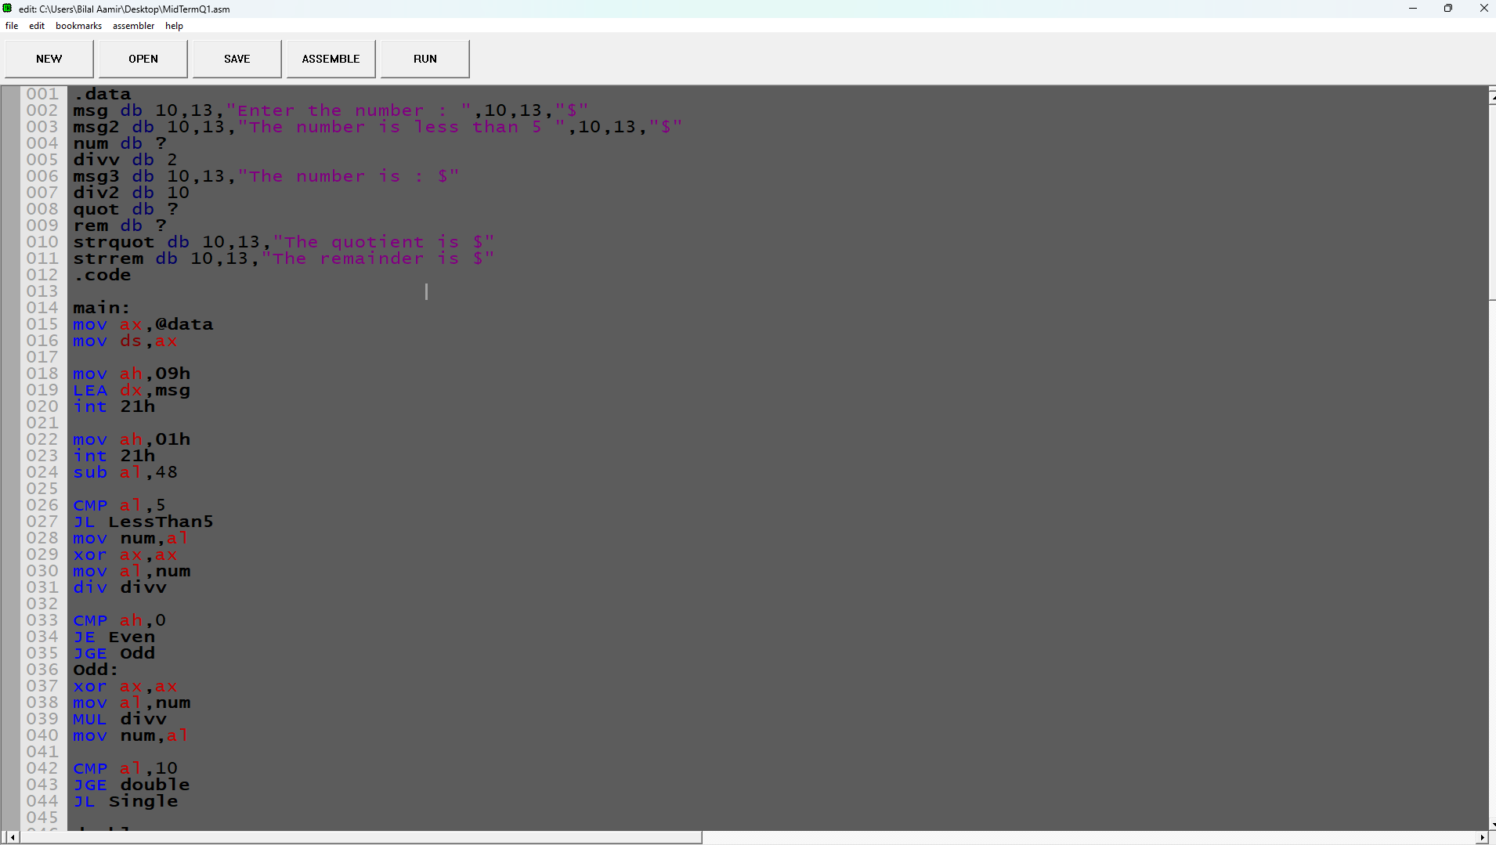

Screenshot (OUTPUT):
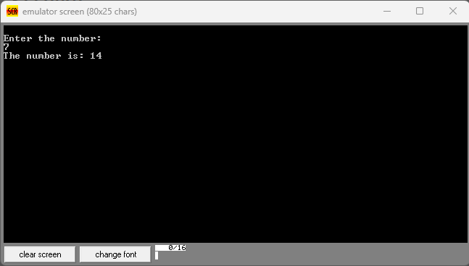
Question No. 2.
Write program in Assembly language that takes a single digit input from user. After taking input, print on screen the letter grade. The program should keep asking for another number in a loop to check the grade of the next student , until the enter key is pressed.
Grading policy is:
8 to 10 | A
5 to 7 | B
3 to 4 | C
< 4 | F
< 0 & > 10 | Invalid input

Code (TEXT):
.model small

.data
msg db 10,13,"Enter the number : $"
invld db 10,13,"Invalid number : ",10,13,"$"
fgrd db 10,13,"Your grade is F ",10,13,"$"
cgrd db 10,13,"Your grade is C ",10,13,"$"
bgrd db 10,13,"Your grade is B ",10,13,"$"
agrd db 10,13,"Your grade is A ",10,13,"$"
entr db 10,13,"You pressed Enter key ",10,13,"$"
num db ?

.code
mov ax,@data
mov ds,ax

MyLoop:

mov ah,09h
LEA dx,msg
int 21h

mov ah,01h
int 21h

CMP al,13
JE ExitLoop

sub al,48

CMP al,0
JL Invalid

CMP al,10
JA Invalid

CMP al,3
JL Fgrade

CMP al,4
JLE Cgrade

CMP al,7
JLE Bgrade

mov ah,09h
LEA dx,agrd
int 21h
JMP Cont

Bgrade:
mov ah,09h
LEA dx,bgrd
int 21h
JMP Cont

Cgrade:
mov ah,09h
LEA dx,cgrd
int 21h
JMP Cont

Fgrade:
mov ah,09h
LEA dx,fgrd
int 21h
JMP Cont

Invalid:

mov ah,09h
LEA dx,invld
int 21h

Cont:

jmp MyLoop

ExitLoop:

mov ah,09h
LEA dx,entr
int 21h

mov ah,4Ch
int 21h

Screenshot (CODE):
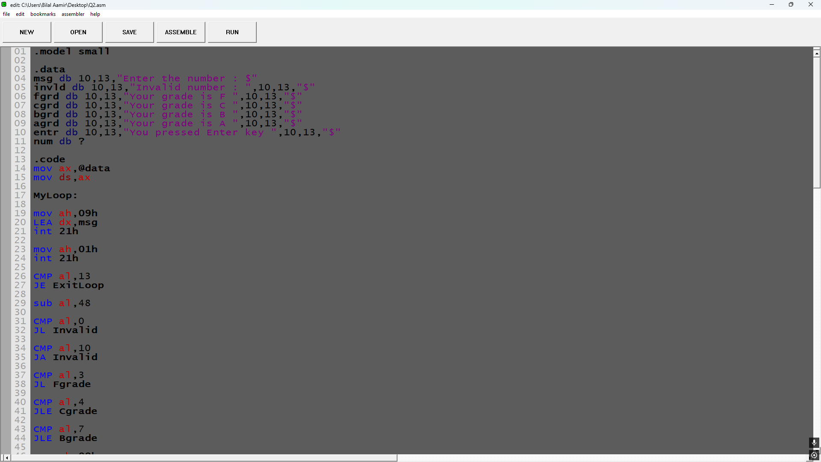

Screenshot (OUTPUT):
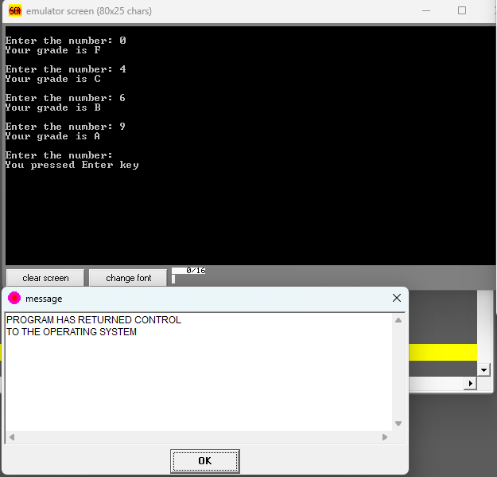
Question No. 3
Write a program in assembly language that takes a single digit number from the user.
- If the input is divisible by 2: User is asked to enter another number, and the sum of both numbers is displayed with an appropriate message. (If the sum is of two digits, print it accordingly)
- If the input is not divisible by 2: Multiply it with 2 and print the result with an appropriate message. (If the Multiplication result is of two digits, print it accordingly)

Code (TEXT):
.model small

.data
msg1 db 10,13,"Enter the number : $"
res db 10,13,"The number is : $"
msg2 db 10,13,"Enter another number : $"
divv db 2
quot db ?
rem db ?
num db ?
num2 db ?

.code
mov ax, @data
mov ds, ax

mov ah, 09h
LEA dx, msg1
int 21h
mov ah, 01h
int 21h
sub al, 48
mov num, al

xor ax, ax
mov al, num
mov divv, 2
div divv

CMP ah, 0
JE Divisible

xor ax, ax
mov al, num
mov divv, 2
MUL divv

CMP al, 10
JGE double_odd

mov num, al
add num, 48
mov ah, 09h
LEA dx, res
int 21h
mov dl, num
mov ah, 02h
int 21h
jmp Cont

double_odd:

mov num, al
mov ah, 09h
LEA dx, res
int 21h
xor ax, ax
mov al, num
mov divv, 10
div divv
mov quot, al
mov rem, ah
add quot, 48
add rem, 48

mov ah, 02h

mov dl, quot
int 21h

mov dl, rem
int 21h

jmp Cont

Divisible:
mov ah, 09h
LEA dx, msg2
int 21h
mov ah, 01h
int 21h
sub al, 48
mov num2, al

xor ax, ax
mov al, num2
mov divv, 2
MUL divv

CMP al, 10
JGE double_even

mov num2, al
add num2, 48

mov ah, 09h
LEA dx, res
int 21h

mov dl, num2
mov ah, 02h
int 21h

jmp Cont

double_even:

mov num2, al
mov ah, 09h
LEA dx, res
int 21h

xor ax, ax
mov al, num2

mov divv, 10
div divv

mov quot, al
mov rem, ah
add quot, 48
add rem, 48

mov ah, 02h

mov dl, quot
int 21h

mov dl, rem
int 21h

Cont:
mov ah, 4Ch
int 21h

Screenshot (CODE):
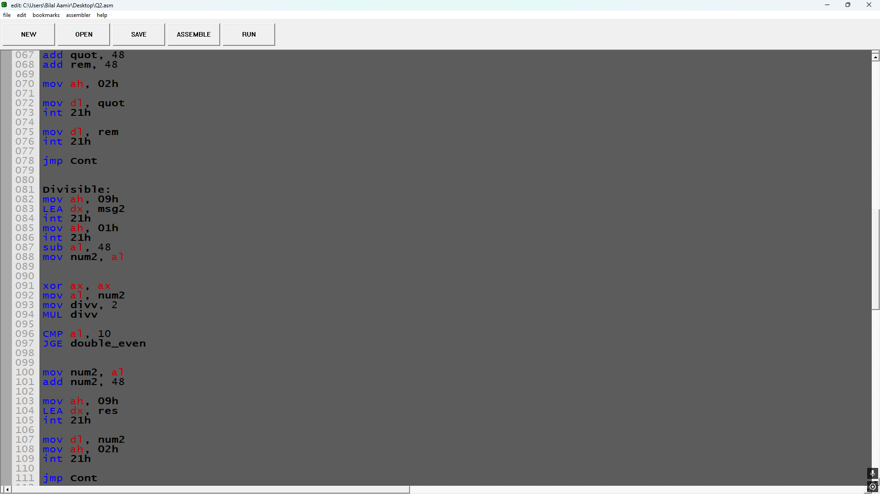

Screenshot (OUTPUT):
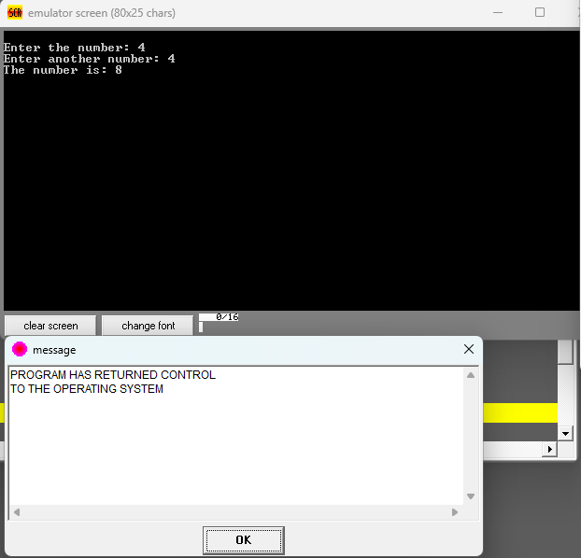
Question No. 4
Implement a switch-case statement in assembly language to determine the day of the week based on a user input. The program should prompt the user to enter a number between 1 and 7 and then print out the corresponding day of the week (e.g. "Monday", "Tuesday", etc.).
- First day of the week is Monday for the sake of this exam.
- In case the number is 0 or greater than 7, print “Invalid Input”

Code (TEXT):
.model small

.data
msg db 10,13,"Enter the number: $"
invld db 10,13,"You entered an invalid number $"
mnd db 10,13,"Monday $"
tus db 10,13,"Tuesday $"
wed db 10,13,"Wednesday $"
thr db 10,13,"Thursday $"
frd db 10,13,"Friday $"
str db 10,13,"Saturday $"
snd db 10,13,"Sunday $"
input db ?

.code
mov ax,@data
mov ds,ax

mov ah,09h
LEA dx,msg
int 21h

mov ah,01h
int 21h

sub al,48
mov input,al

CMP al,0
JE Invalid

CMP al,7
JG Invalid

CMP al,1
JE Monday

CMP al,2
JE Tuesday

CMP al,3
JE Wednesday

CMP al,4
JE Thursday

CMP al,5
JE Friday

CMP al,6
JE Saturday

mov ah,09h
LEA dx,snd
int 21h

jmp Cont

Monday:
mov ah,09h
LEA dx,mnd
int 21h

jmp Cont

Tuesday:

mov ah,09h
LEA dx,tus
int 21h

jmp Cont

Wednesday:
mov ah,09h
LEA dx,wed
int 21h

jmp Cont

Thursday:

mov ah,09h
LEA dx,thr
int 21h

jmp Cont
Friday:

mov ah,09h
LEA dx,frd
int 21h

jmp Cont

Saturday:

mov ah,09h
LEA dx,str
int 21h

jmp Cont

Invalid:
mov ah,09h
LEA dx,invld
int 21h

Cont:

mov ah,4Ch
int 21h

Screenshot (CODE):
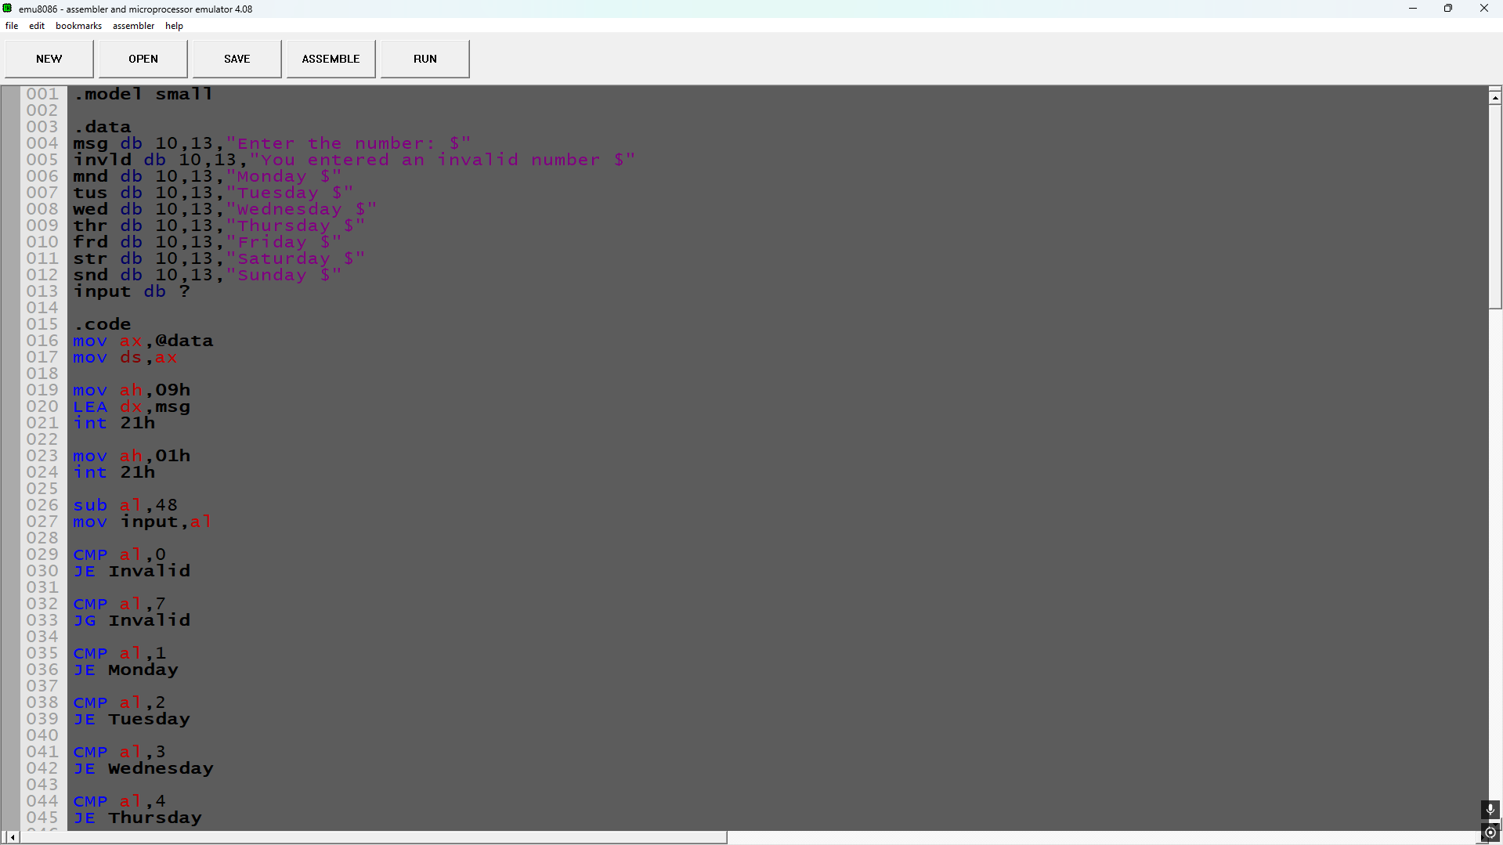

Screenshot (OUTPUT):
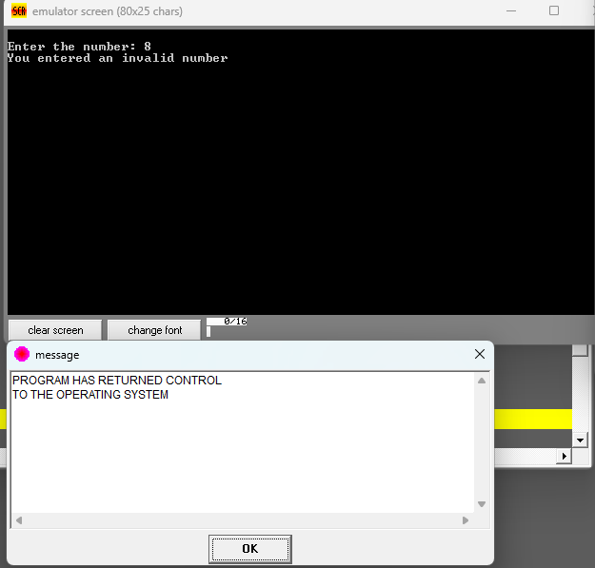

Lab Task

Task 1:
Code (TEXT):
.data
msg1 db 10,13,"Enter the number : $"
msg2 db 10,13,"The number of even numbers is : $"
msg3 db 10,13,"The number of odd numbers is : $"
msg4 db 10,13,"More even numbers $"
msg5 db 10,13,"More odd numbers $"
msg6 db 10,13,"Equal even and odd numbers $"
even_count db 0
odd_count db 0
arr db ?

.code
main:
mov ax,@data
mov ds,ax

mov cx,10
mov si,0

MyLoop: ; Loop to store numbers
mov ah,09h
LEA dx,msg1
int 21h

mov ah,01h
int 21h
sub al,48

mov arr[si],al
inc si
xor ax,ax

Loop MyLoop

mov cx,10
mov si,0
xor ax,ax
mov bl,2

MyLoop2: ;Loop to count even odd

mov al,arr[si]

div bl

cmp ah,0
JE Even

inc odd_count
jmp Cont:

Even:
inc even_count

Cont:

xor ax,ax
inc si
Loop MyLoop2

;Print Even Count
mov ah,09h
LEA dx,msg2
int 21h

mov ah,02h
mov dl,even_count
add dl,48
int 21h

;Print Odd Count
mov ah,09h
LEA dx,msg3
int 21h

mov ah,02h
mov dl,odd_count
add dl,48
int 21h

;Check even more or odd
mov bl,odd_count

CMP even_count,bl
JE Equal
JL More_Odd
JG More_Even
JMP Cont2

Equal:

mov ah,09h
LEA dx,msg6
int 21h

jmp Cont2

More_even:
mov ah,09h
LEA dx,msg4
int 21h

jmp Cont2

More_Odd:
mov ah,09h
LEA dx,msg5
int 21h

Cont2:

mov ah,4Ch
int 21h
end main

Screenshot (CODE):
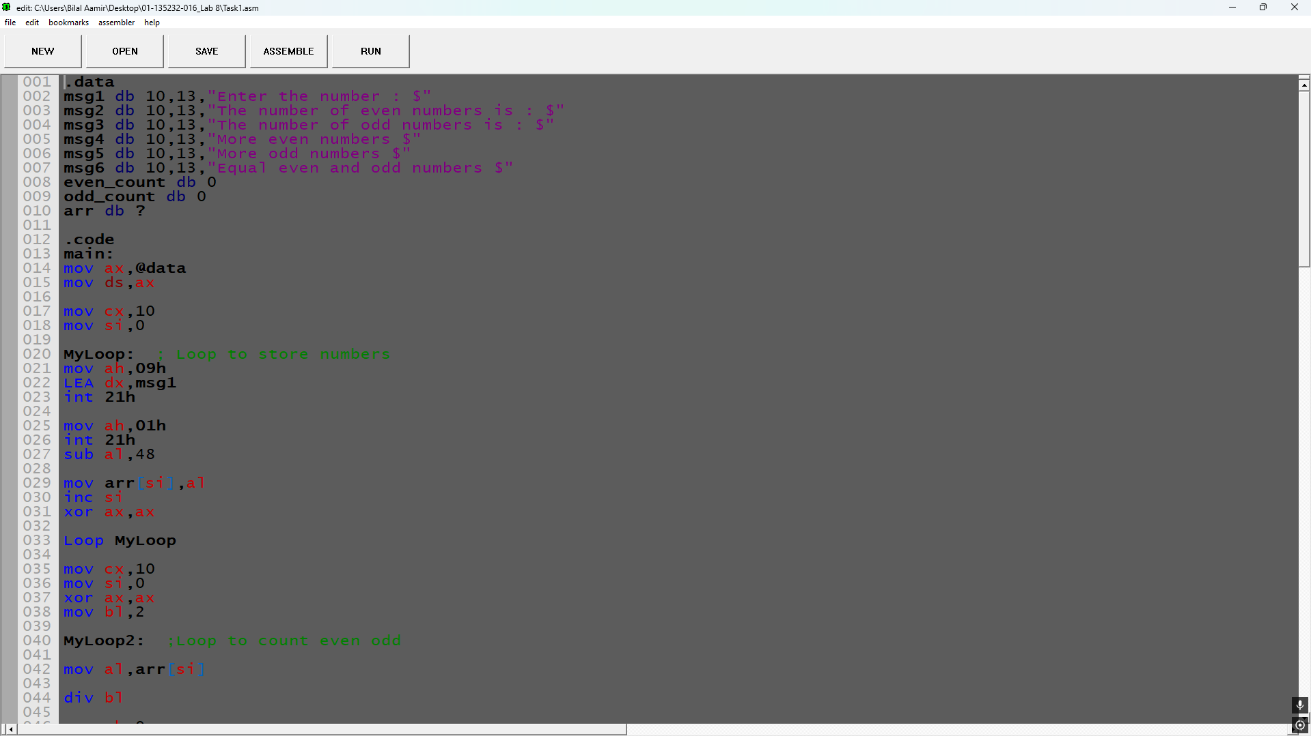

Screenshot (OUTPUT):
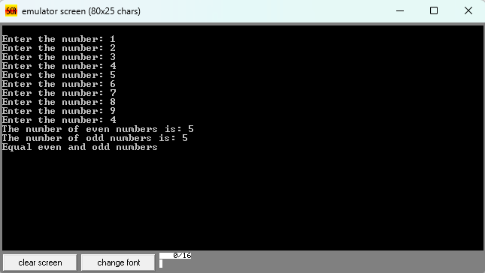

Task 2:
Code (TEXT):
.data
msg1 db 10,13,"Enter the number : $"
msg2 db 10,13,"Array in reverse Order: $"
arr db ?

.code
main:
mov ax,@data
mov ds,ax

mov cx,10
mov si,0

MyLoop: ; Loop to store numbers
mov ah,09h
LEA dx,msg1
int 21h

mov ah,01h
int 21h
sub al,48

mov arr[si],al
inc si
xor ax,ax

Loop MyLoop

mov ah,09h
LEA dx,msg2
int 21h

mov cx,10
mov si,9
Reverse:

mov ah,02h

mov dl,arr[si]
add dl,48
int 21h

dec si

CMP cl,0
Loop Reverse

mov ah,4Ch
int 21h
end main

Screenshot (CODE):
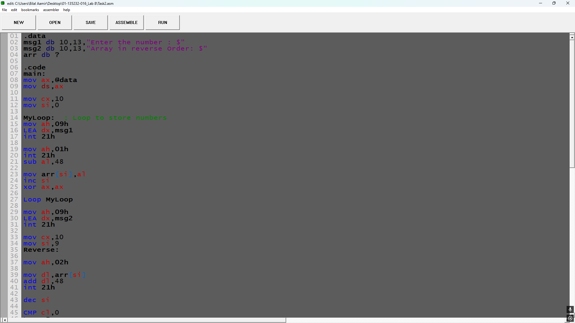

Screenshot (OUTPUT):
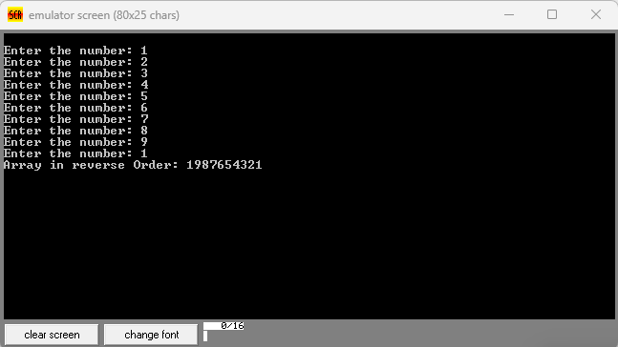

Task 3:
Code (TEXT):
.model small

.data
msg1 db 10,13,"Enter the number : $"
outerback db ?
innerback db ?
msg2 db 10,13,"The Sorted Array is :",10,13,"$"
arr db ?

.code
main:
mov ax,@data
mov ds,ax

mov cx,10
mov si,0

MyLoop: ; Loop to store numbers
mov ah,09h
LEA dx,msg1
int 21h

mov ah,01h
int 21h
sub al,48

mov arr[si],al
inc si
xor ax,ax

Loop MyLoop

xor ax,ax
mov cx,9

OuterLoop:
mov outerback,cl
mov si,0

InnerLoop:

mov al,arr[si]
mov bl,arr[si+1]
CMP al,bl
JAE Cont

XCHG al,bl
mov arr[si],al
mov arr[si+1],bl

Cont:
inc si
dec outerback
CMP outerback,0
JE ExitInner

JMP InnerLoop

ExitInner:
loop OuterLoop

mov ah,09h
LEA dx,msg2
int 21h

mov cx,10
mov si,0

MyLoop2:

mov ah,02h

mov dl,arr[si]
add dl,48
int 21h

inc si

Loop MyLoop2

mov ah,4Ch
int 21h

Screenshot (CODE):
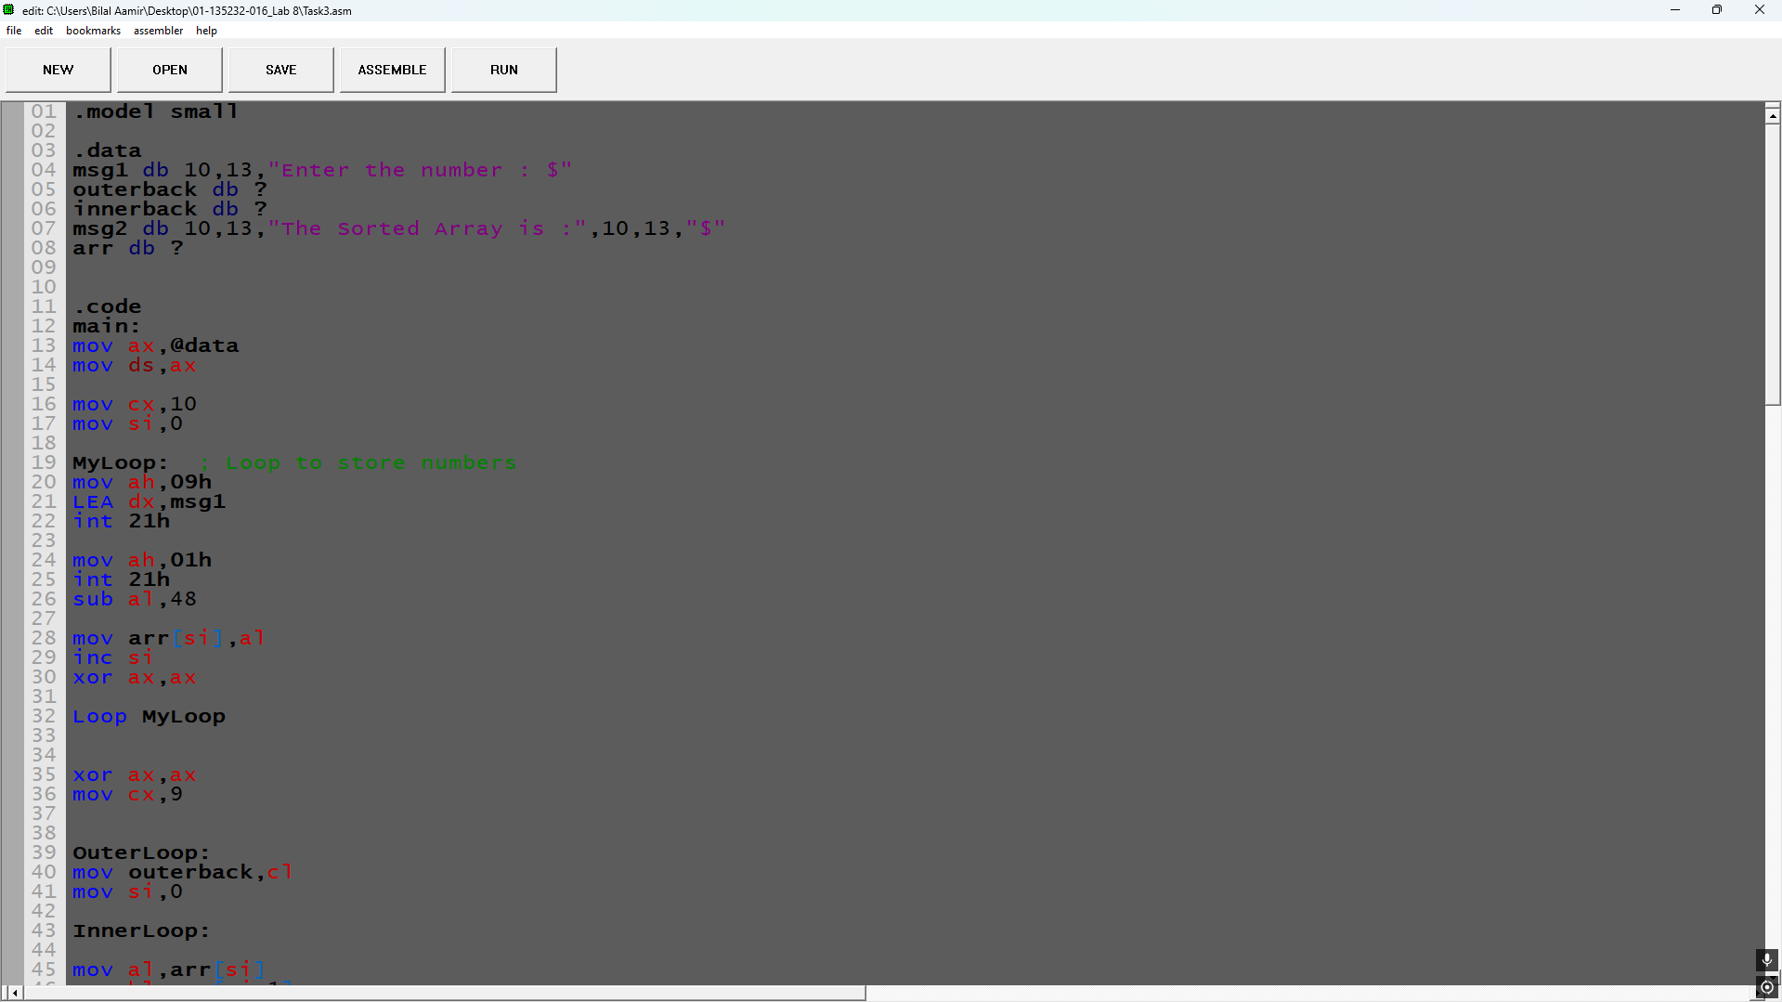

Screenshot (OUTPUT):

